Using the Database  
CS 470 Full Stack Development II

Sergio Mateos

Southern New Hampshire University

* Part One: The Query Lambda
  1. Graphical user interface, application, Teams

     Description automatically generatedCreate a new Lambda.

* 1. Graphical user interface, text, application, email

     Description automatically generatedQuestionWithoutFilter
  2. 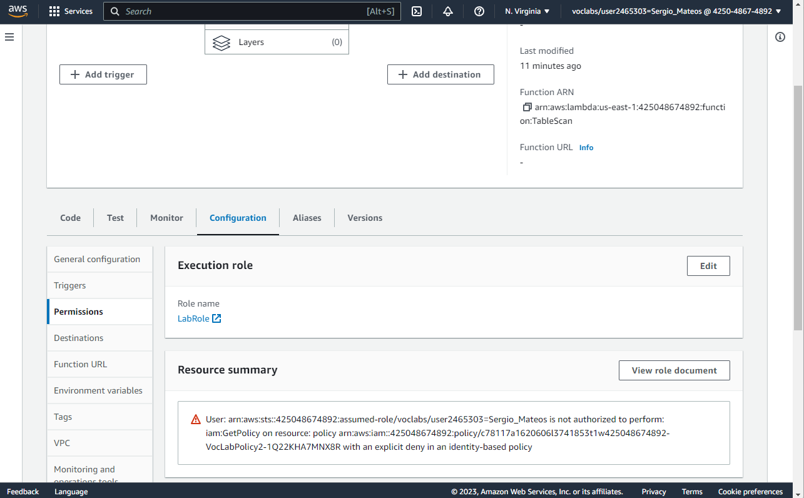Permissions
  3. Graphical user interface, text, application

     Description automatically generated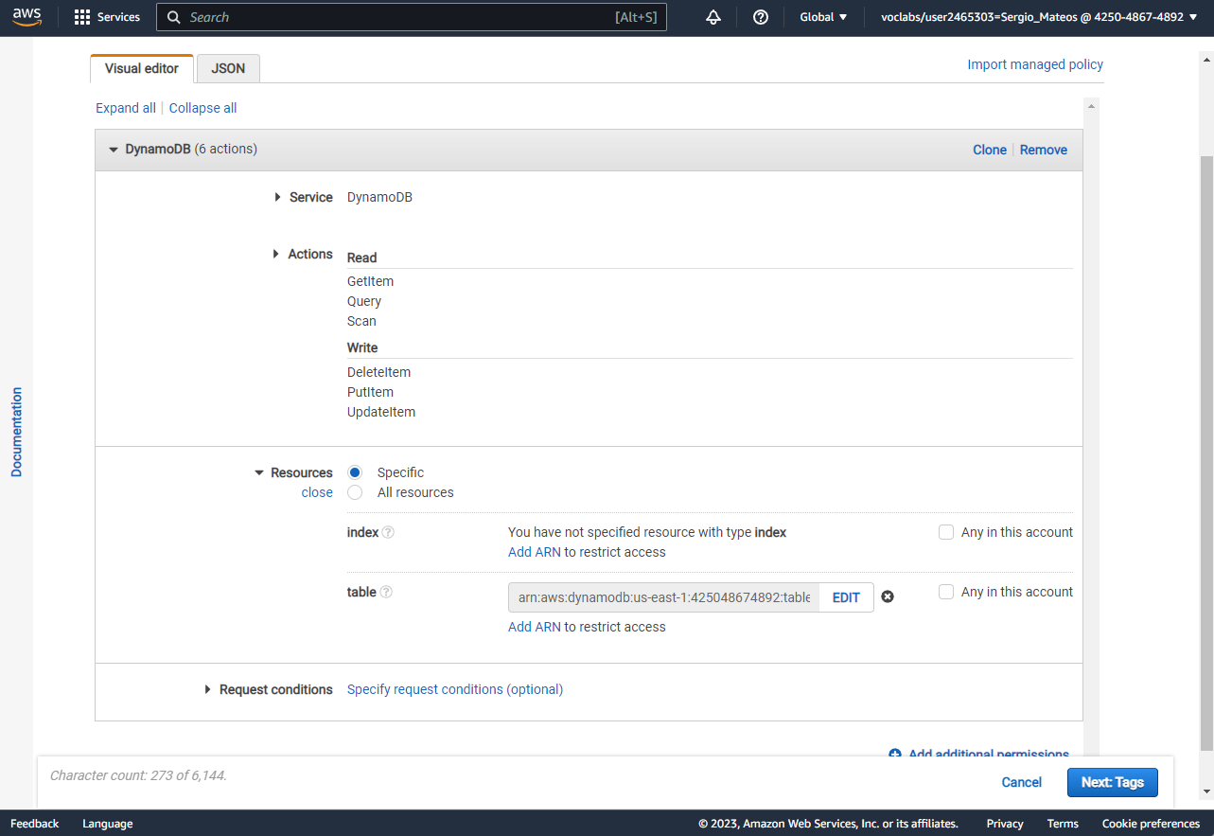Create a new policy.

* 1. 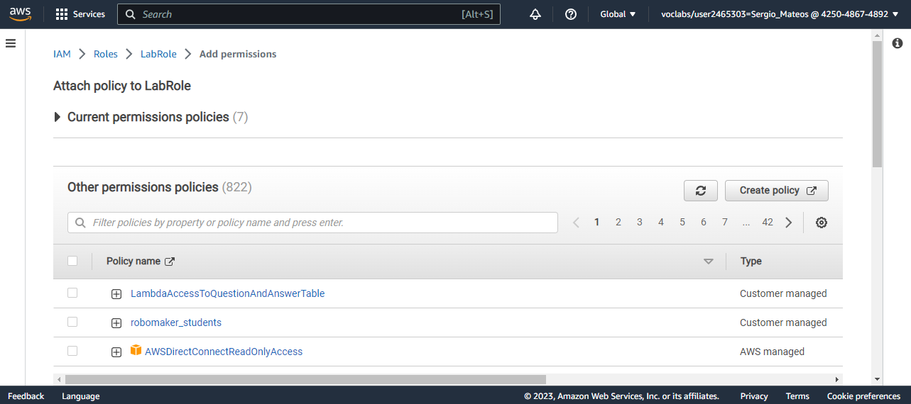Attach Policy
  2. 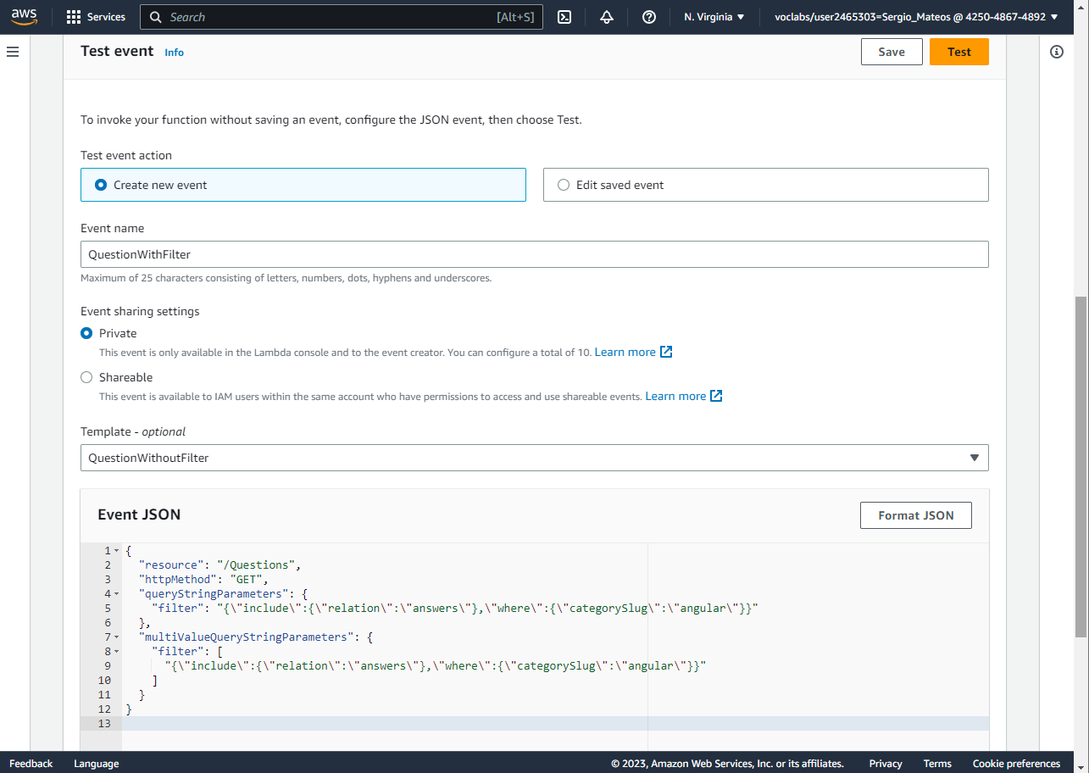Create a new test “QuesionWithFilter”
  3. 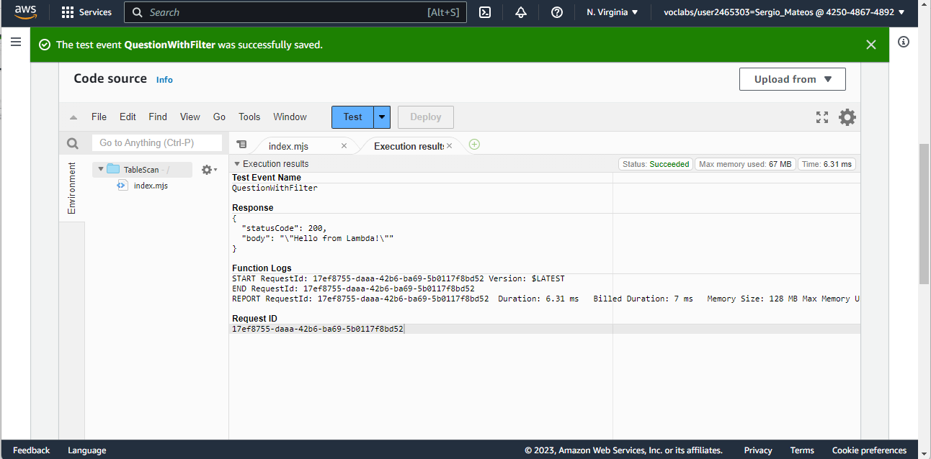Test
  4. 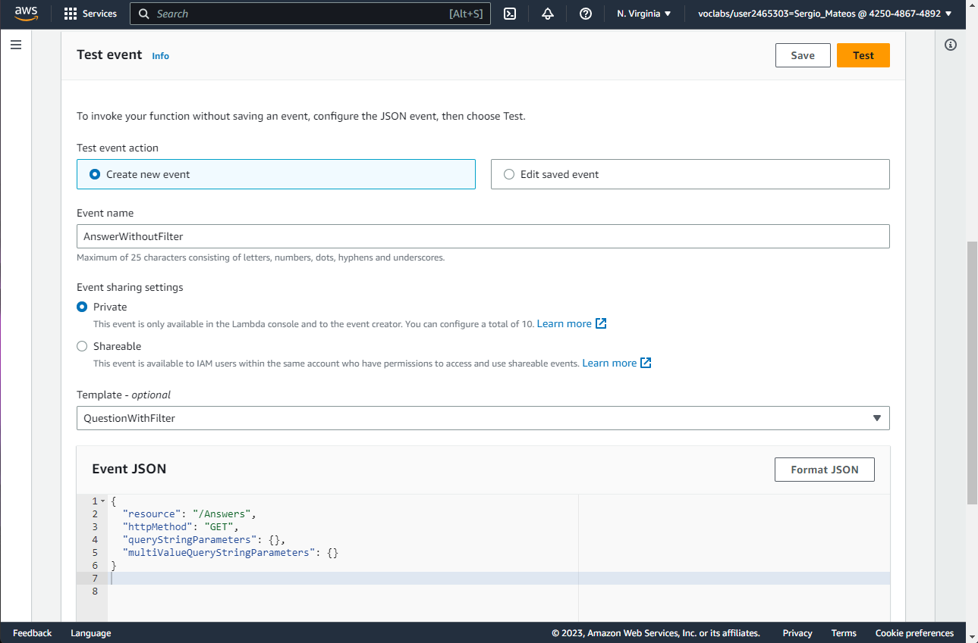Create a new test “AnswerWithoutFilter”.
  5. 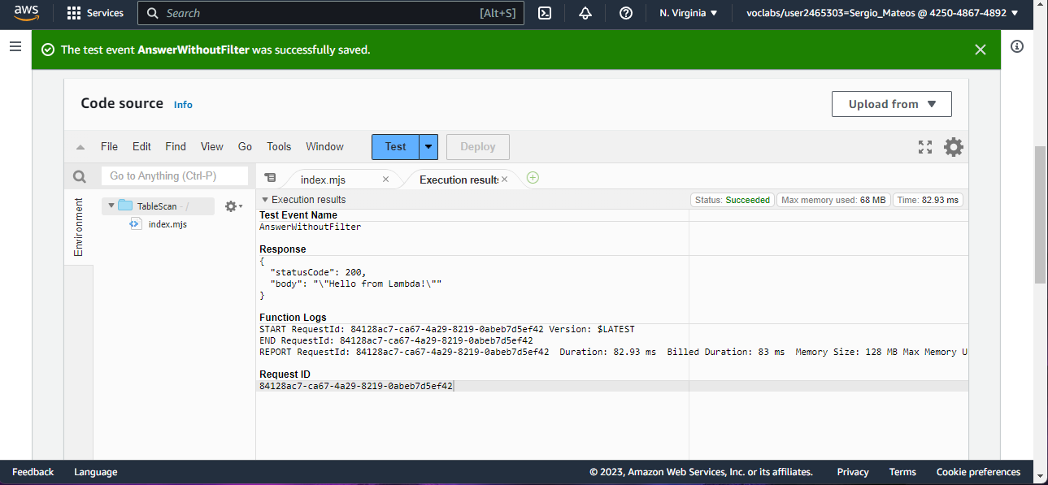Test
* Part Two: Single Record Fetch
  1. Graphical user interface, text, application, email

     Description automatically generatedCreate Lambda “GetSingleRecord”

* 1. Graphical user interface, text, application, email

     Description automatically generatedIndex file in the “GetSingleRecord”
  2. Graphical user interface, text, application, email

     Description automatically generatedNew test event “TestGetQuestion”
  3. 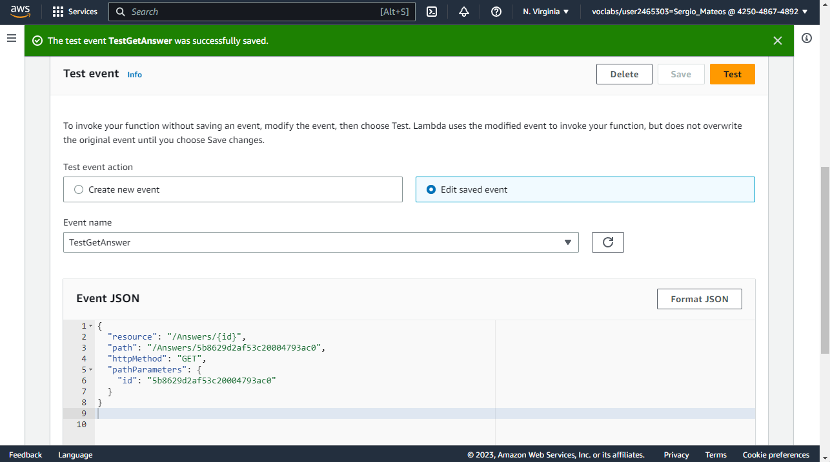New test event “TestGetAnswer”.
  4. Graphical user interface, text, application, email

     Description automatically generatedGraphical user interface, application

     Description automatically generatedCreate Lambda “FindOneQuestion”
* Part Three: Upserting Records
  1. Graphical user interface, application

     Description automatically generatedCreate Lambda “UpsertQuestion”
  2. 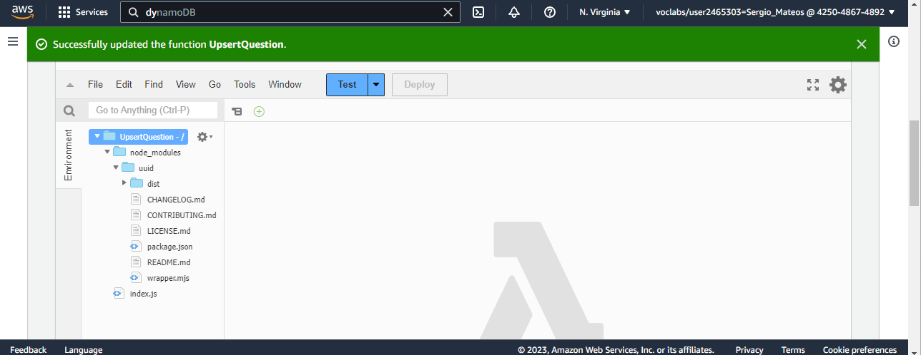Upload zip file
  3. Graphical user interface, text, application, email

     Description automatically generatedCreate event “TestPost”.
  4. Graphical user interface, text, application, email

     Description automatically generatedTest
  5. Graphical user interface, application

     Description automatically generatedCreate Lambda “UpsetAnswer”
  6. A picture containing application

     Description automatically generatedUpload zip file
  7. Graphical user interface, text, application, email

     Description automatically generatedCreate test event “TestPost”
  8. Test

* Part Four: Deleting Records
  1. 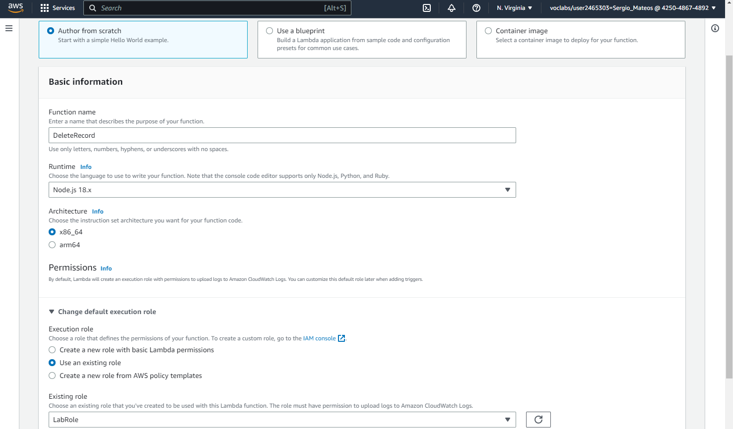Create Lambda “DeleteRecord”
  2. Graphical user interface, text, application

     Description automatically generatedIndex file
  3. Create test event “TestDeleteQuestion”.

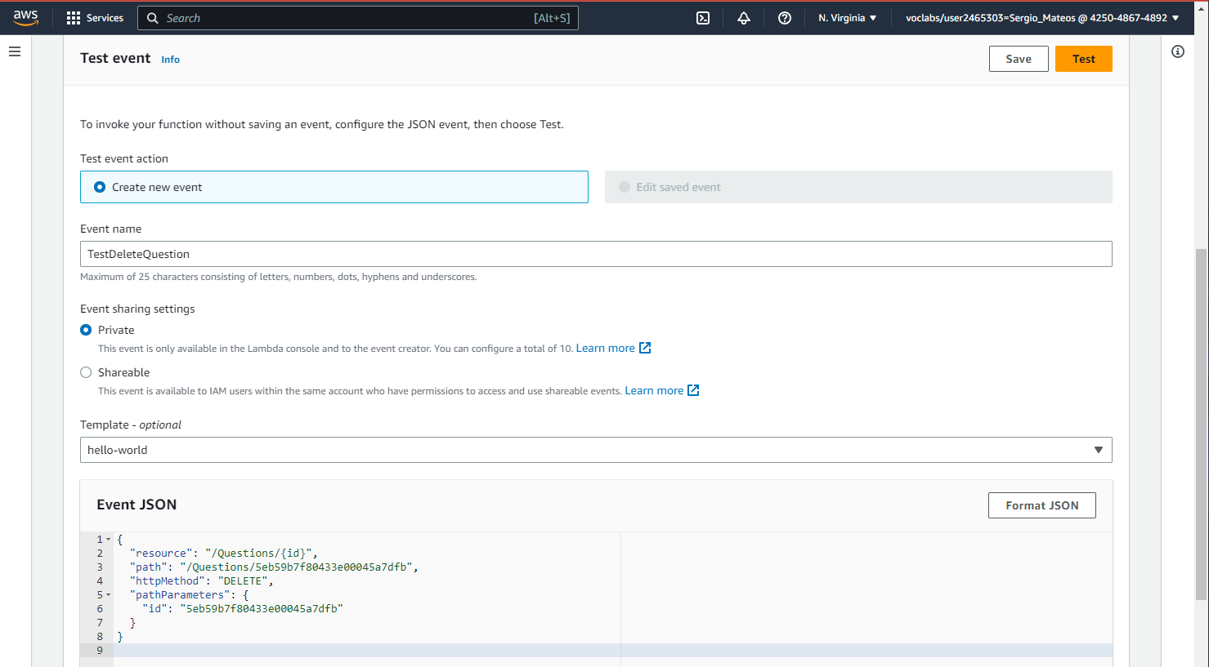

* 1. Graphical user interface, text, application, email

     Description automatically generatedTest
  2. Create test event “TestDeleteAnswer”.

* 1. Graphical user interface, text, application, email

     Description automatically generatedTest